PARALLEL AND DISTRIBUTIVE COMPUTING (UCS645)
LAB – 1
By
Aditya Chauhan
102496001
3P14
Instructor: Dr. Saif Nalband
THAPAR INSTITUTE OF ENGINEERING AND
TECHNOLOGY, (A DEEMED TO BE UNIVERSITY),
PATIALA, PUNJAB INDIA
Session-Year (Jan-May, 2026)

Q1. DAXPY Loop Analysis: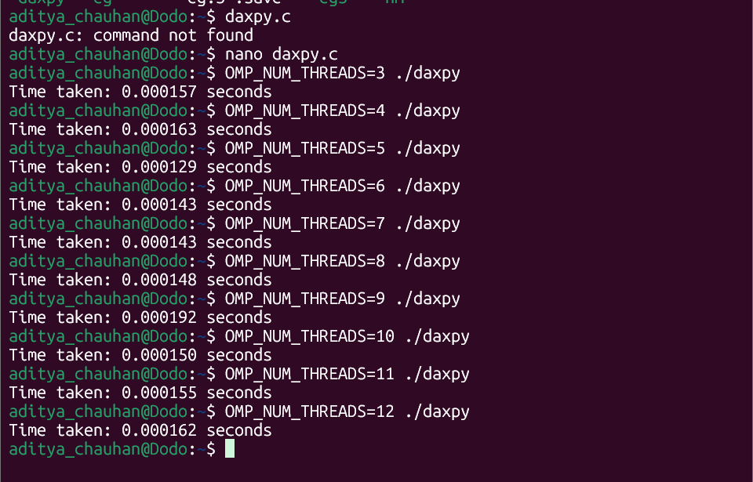
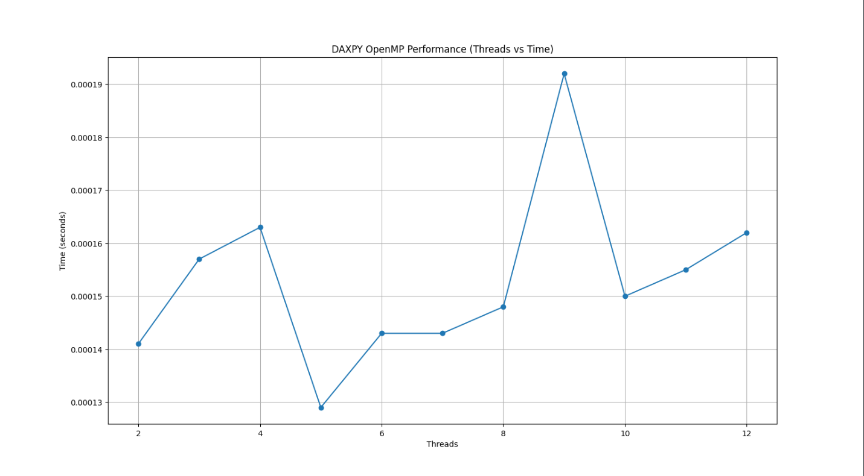
Observation :
From the execution time graph, it is observed that increasing the number of threads does not significantly improve performance. In fact, after a small number of threads, the execution time increases. This happens because DAXPY is a memory-bound operation where threads compete for memory bandwidth and cache resources. Therefore, DAXPY shows poor scalability with OpenMP and performs best with fewer threads.

Q2. Matrix Multiplication Analysis:

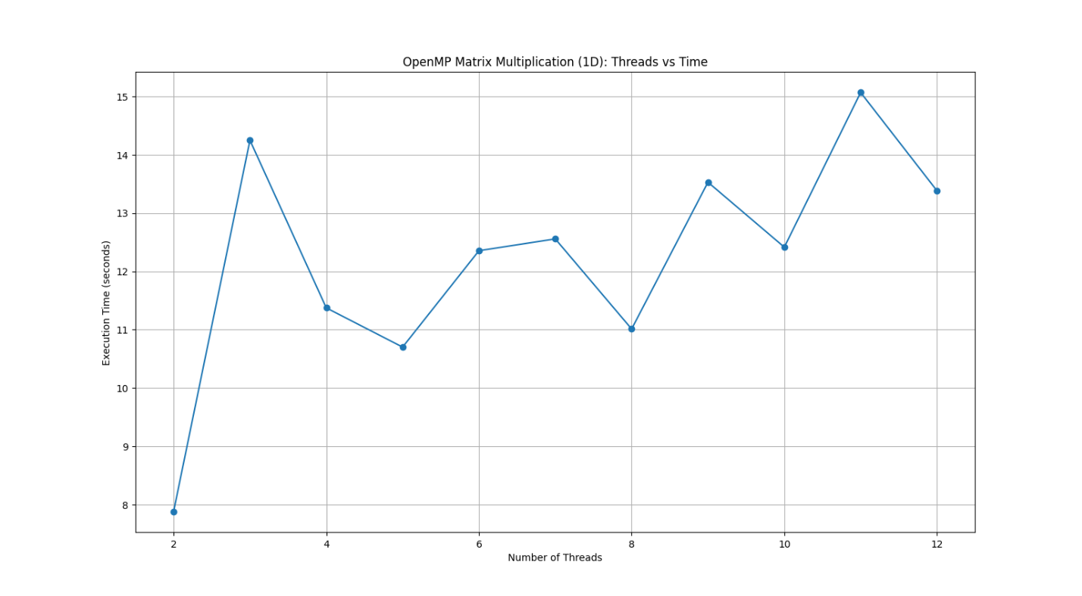

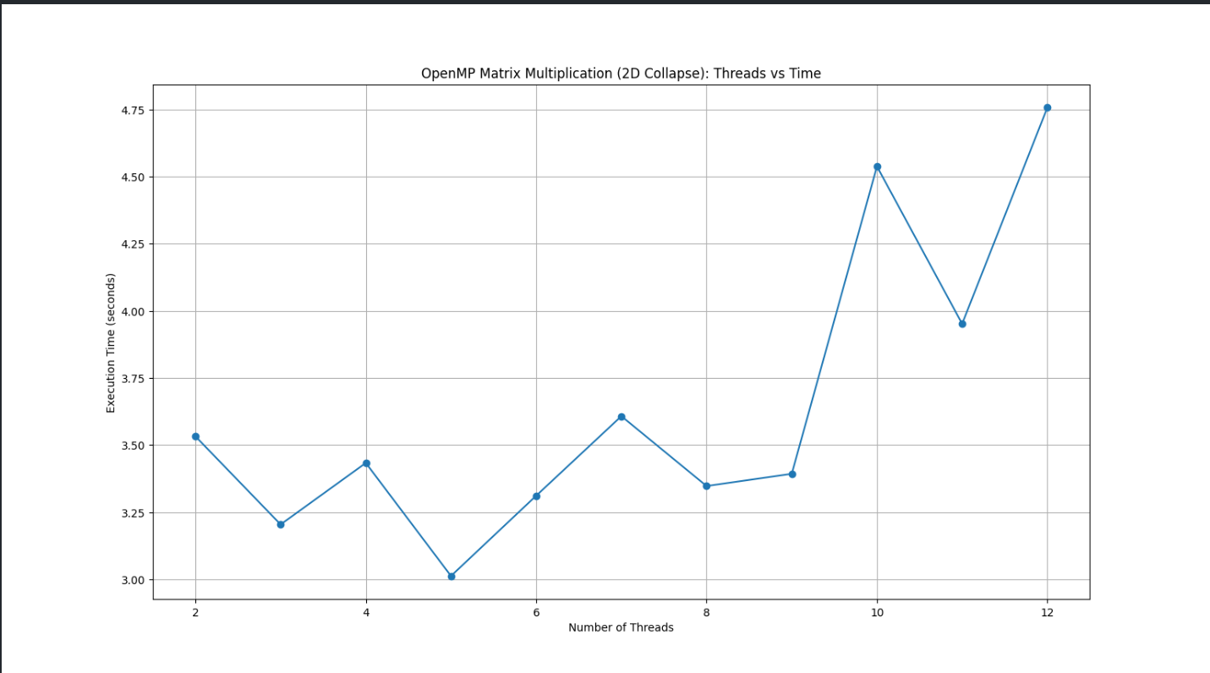

Observation: The results show a clear reduction in execution time as the number of threads increases, demonstrating good parallel scalability. Since matrix multiplication is compute-intensive, the workload is effectively distributed across threads, leading to significant speedup. The 2D collapse strategy performs better than 1D threading because it improves load balancing and reduces idle time among threads. However, after a certain thread, performance begins to degrade due to overheads.

Q3. π Calculation Analysis:
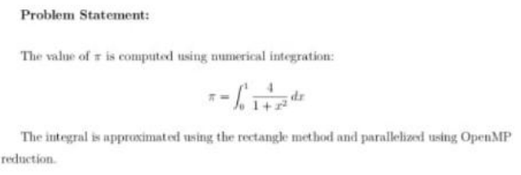

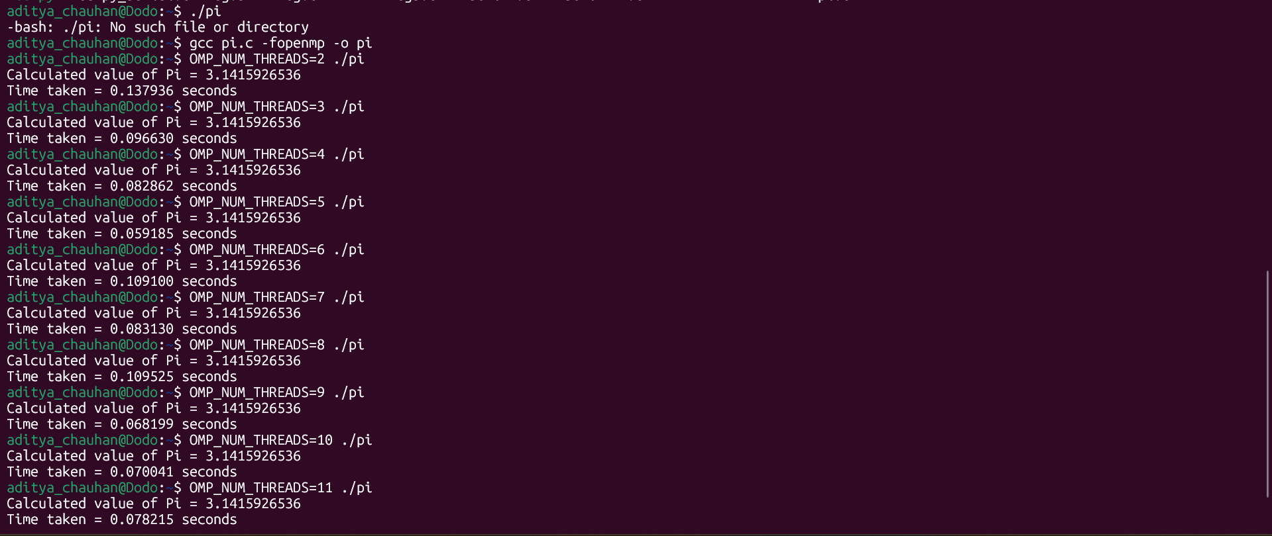
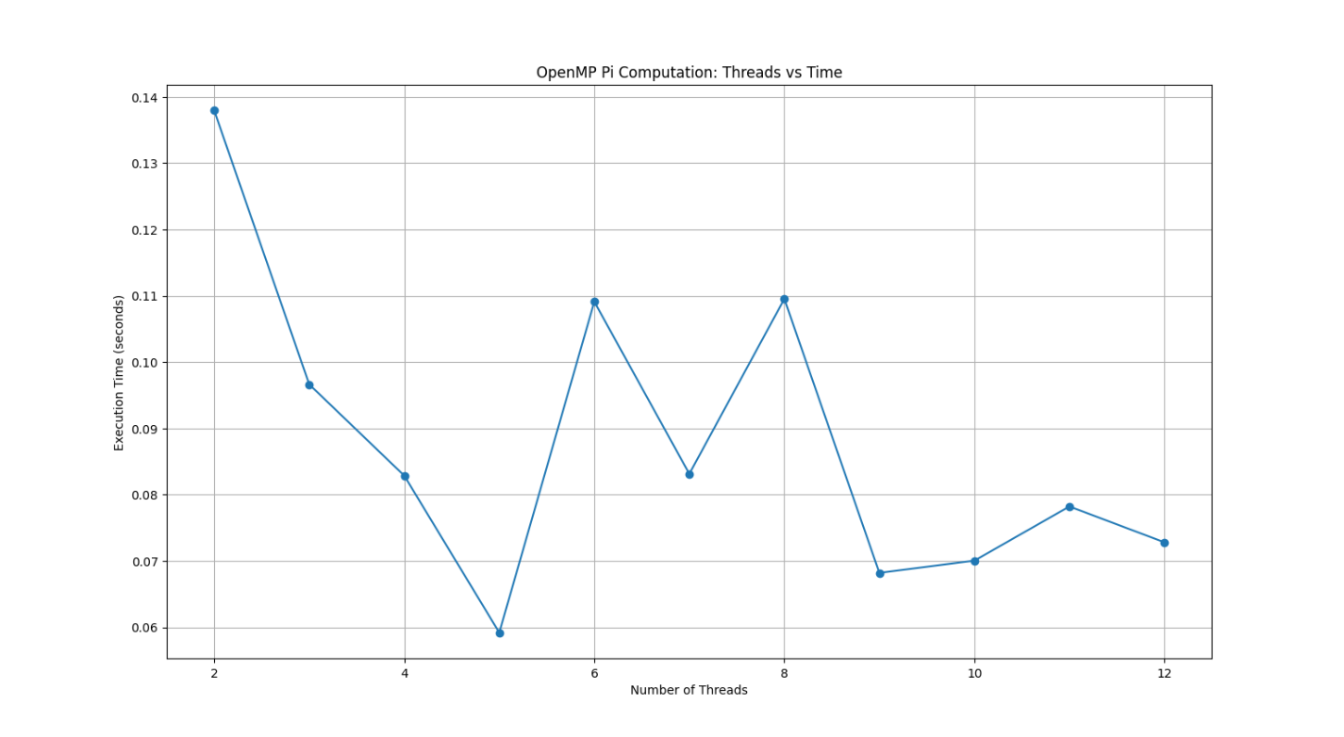
Observation:
The parallel reduction approach significantly improves performance compared to the
serial implementation. Execution time decreases steadily as the number of threads
increases up to the number of available CPU cores. Beyond this point, the
performance gain saturates and may slightly degrade due to synchronization
overhead and thread management costs.

